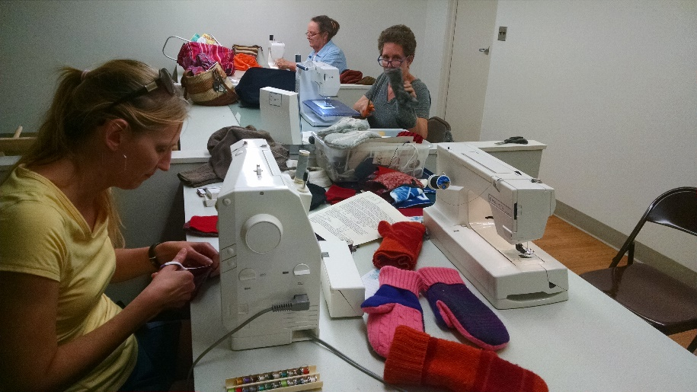
The Community Mitten Project
at Salt Valley Arts Center Studio Spaces

At EHM Senior Solutions Professional Building
400 W. Russell, Entrance A
Nancy Miller will be teaching a free class in making sweater mittens. The mittens or money from the sale of mittens will be donated to Saline Area Social Service.

Dates: Cutting Mittens: Bring sharp scissors!
Tuesday January 17, 2023 10 am to 3 pm,
Wednesday January 18, 2023 10 am to 3 pm
Sewing mittens:
Bring your machine or reserve one of our vintage machines.
Bring thread, wound bobbins, scissors, ripper
Thursday January 19, 2023 10 am to 3 pm

