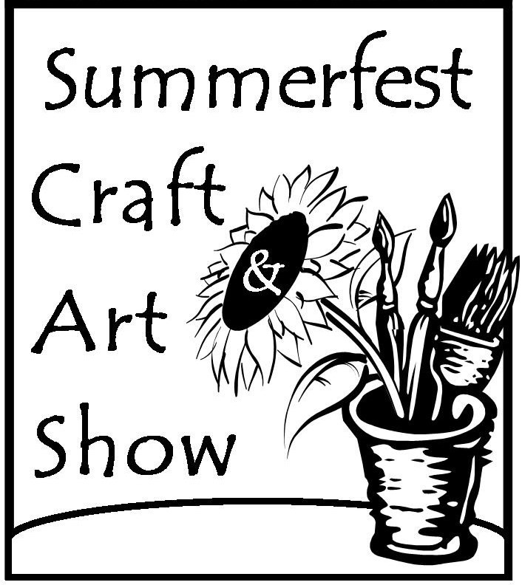
2020 Artist Application
Saline Summerfest
Juried Craft & Art Show
Friday, August 7, 5 - 9 pm
Saturday, August 8, 10 am - 8 pm
Name_______________________________________________________________________
Address_____________________________________________________________________ City________________________________State________________ZipCode_____________ Phone ______________________________ Cell Phone_______________________________
E-Mail_______________________________Website_________________________________ Emergency Contact____________________________________Phone____________________
Media________________________________________ Price Point____________________ Detailed Description Work_______________________________________________________
_____________________________________________________________________________
Special Requests _______________________________________________________________ ______________________________________________________________________________

All applications are due March 30 with applicants notified by April 11. After that date applications will be reviewed as space is available, with a wait list established. Three photos of your work and one of your booth must be submitted with application (via email, pointer to website, CD or hard copy).

I have read and agree to abide by the attached rules and regulations on page 2 of this application and certify the accuracy of the foregoing statements. In addition, I understand that as an applicant/ participant, I hereby release and forever discharge Salt Valley Arts, Picnic in the Park, the City of Saline and all other participating and sponsoring organizations from any responsibility, personal liability, loss or damage in connection with this show. Salt Valley Arts reserves the right to make final interpretation of the rules. Any application is a commitment to the show.

I confirm that the works entered, exhibited, and sold are created by myself.

Signature_____________________________________________________Date________________

Make check out to SVA and mail it and application to: Salt Valley Arts
PO Box 588
Saline, MI 48176
For credit card payment see the “purchase” section of our website www.saltvalleyarts.org

10’ x 10’ booth $75 10’x10’corner booth $90 Electricity $20

For questions or concerns contact Cindy Baxter 734-678-5619 or info@saltvalleyarts.org
____________________________________________________________________________________ For Committee Use
Date Booth Fee Paid______________ Check Number______________ Booth Number__________
2020 Artist Application
Saline Summerfest

Juried Craft & Art Show
Friday, August 7, 5-9 pm
Saturday, August 8, 10 am– 8 pm

(please keep a copy of this page for your records)
- Three photos of your work and one of booth must accompany application. These may be sent via email, via a pointer to a website, hard copy photos, or CD. Material sent will not be returned.
- Applications are due March 30 and artists will be notified by email or letter as to their status by April 11. A wait list will then be used to fill booths.
- All work exhibited must be original and handcrafted by the artist. The limited use of manufactured with items will be allowed, only if incidental to the final product. The artist or their representative must be present with their work for the entire event. No buy/sell or flea market merchandise is allowed.
- Booth fee is $75.00 for a 10’ by 10’ booth or $90.00 for a 10’ by 10’ corner booth if available. There are limited quantities of corner booths. Electricity is $20.00 and a 20-foot outdoor quality extension cord must be provided by the artist. Checks are payable to SVA and must accompany the application, credit cards may be used on the SVA website (see page 1 for details). Checks will be cashed when artists are accepted by the jury.
- Artists may share a booth, but images of work and names of all participants must be included with the initial applications.
- Artists are responsible for providing their own tent, tables, chairs and any display materials.
- There will be no refunds after June 1, 2020. Cancellations after this date are non-refundable. NO refunds will begiven due to cancellation of the event by an act of god, local authorities, or a weather-related incident.
- All artists are expected to handle State of Michigan Sale tax appropriately. A concessionaire’s form will be provided in the artist’s welcome packet.
- A security guard will be on site overnight Friday; however, artists are responsible for insurance and protection of their property as stated on page one of the application.
- All inventory, storage boxes, artwork, etc. must be contained within the booth space and may not be stored on the sidewalk, lawn, etc. NO space adjacent or behind booth is guaranteed for chairs, a table, etc.
- Any audio or visual effects (music, flashing lights, etc.) must be contained within the artist’s booth to not interfere with adjacent booths.
- Exhibitors agree to conduct themselves in a respectful, co-operative manner. Summerfest is a family friendly event and does not wish to include radical, disturbing displays or outbursts of any kind.
- No smoking is allowed within the one block show area.
- Violation to comply with any of these rules will result in immediate expulsion.
- The Summerfest Craft & Art Show is put on by the Salt Valley Arts and is part of a larger event. Please visit www.salinesummerfest.org to see all the activities.
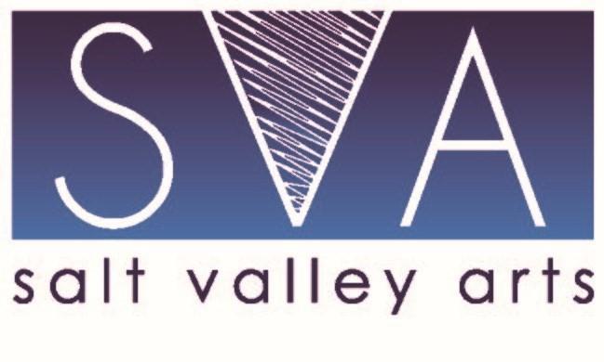

Salt Valley Arts

Contact: Cindy Baxter 734-678-5619

PO Box 588

info@saltvalleyarts.org

Saline, Michigan 48176
www.saltvalleyarts.org

